Colorsmatrimonial issues Assigned by Narender

1)Membership : Free/silver/Gold/platinum
Agent: username : AG0133 pass: spark
http://colorsmatrimony.com/agents/view_search_results.php

profile download kavali(DONE)

http://colorsmatrimony.com/agents/download_profile.php?cid=CM0076(done)

http://colorsmatrimony.com/agents/step_two.php?uid=CM0044(DONE)
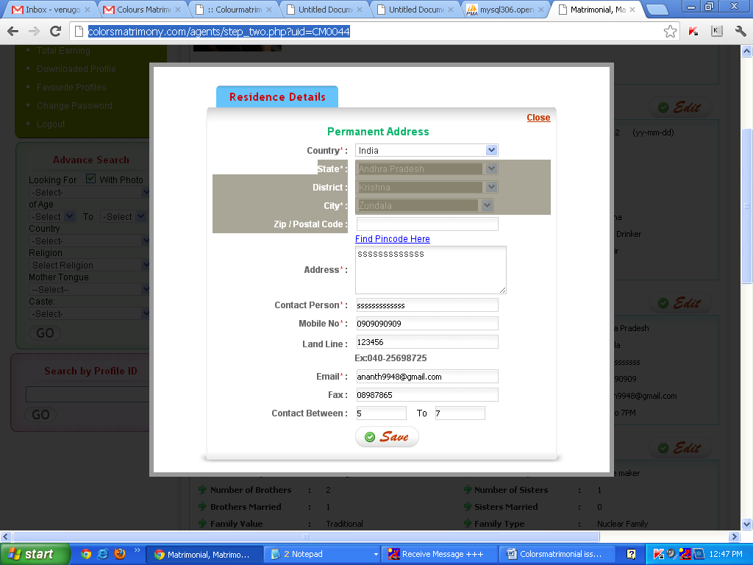
Above page is Profile_informaion.php

Session Page done ex:
**city showing default values
http://colorsmatrimony.com/agents/search_for_desired_partner.php

**Images in all pages

Left
Colorsmatrimonial issues Assigned by Praveen
1)Contact details country ,state,district, city

3) Suitable profile
4) membership : Gold

