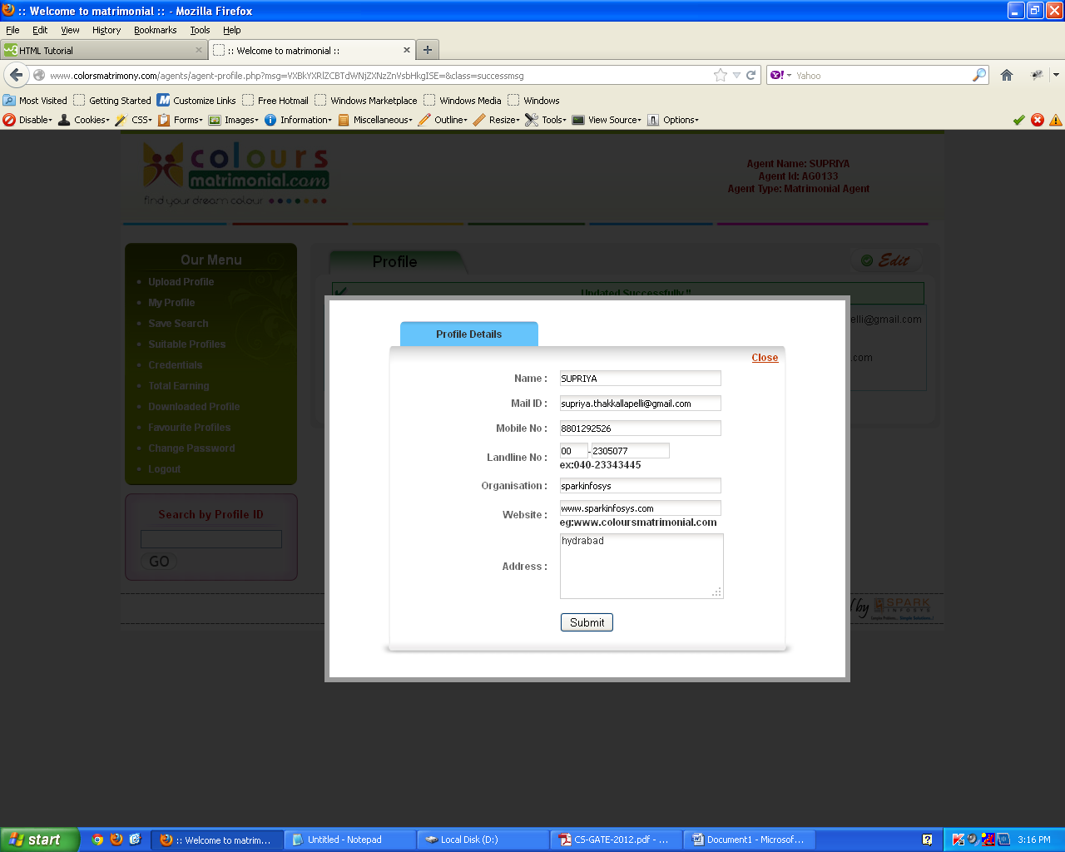
- Profile details-> In landline number , code accepting 3 numbers only(i.e; 040)..and empty also

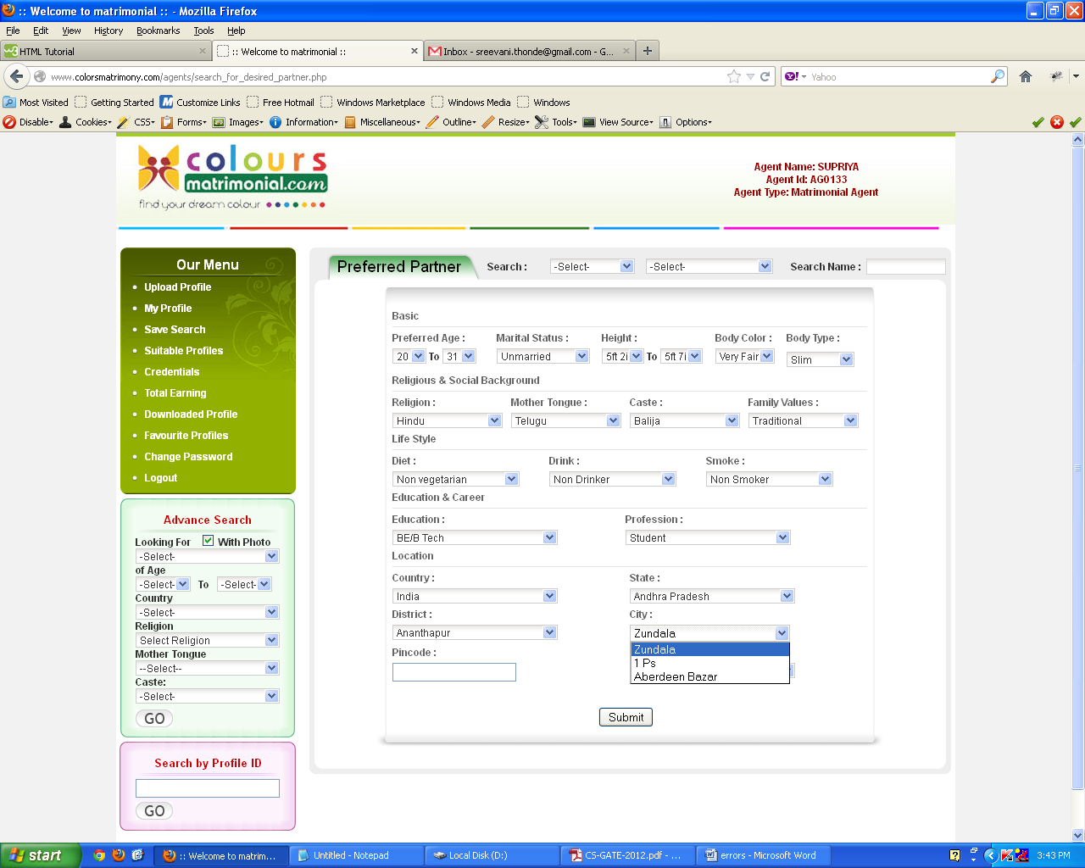
- Preferred patner->city->no other options
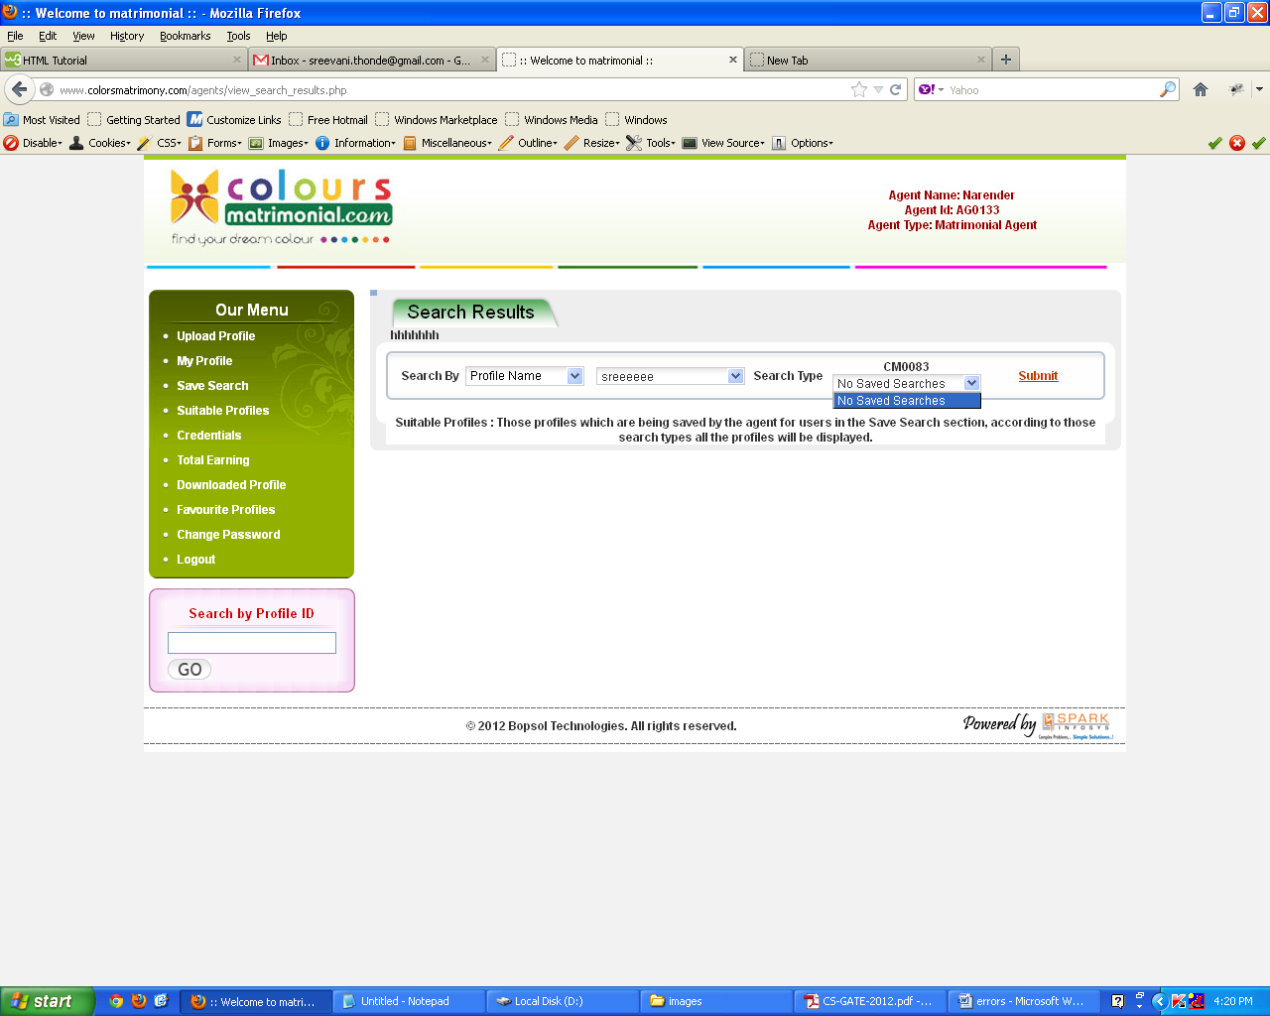

- Search Results->search by name->after submitting name or id ,again it is asking
Search type

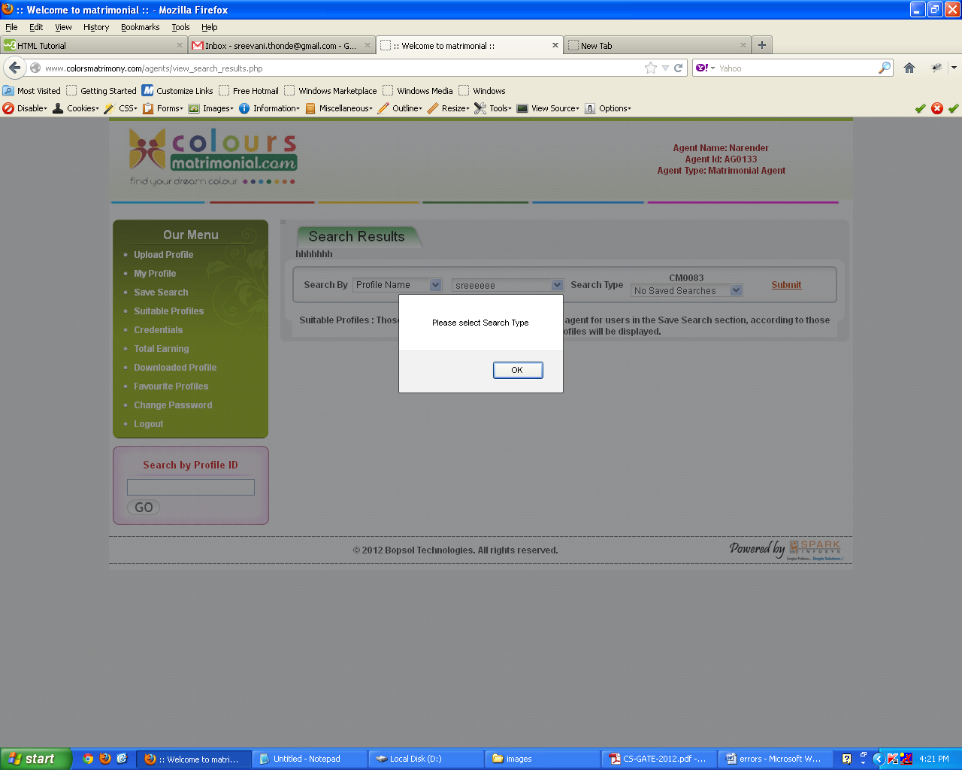
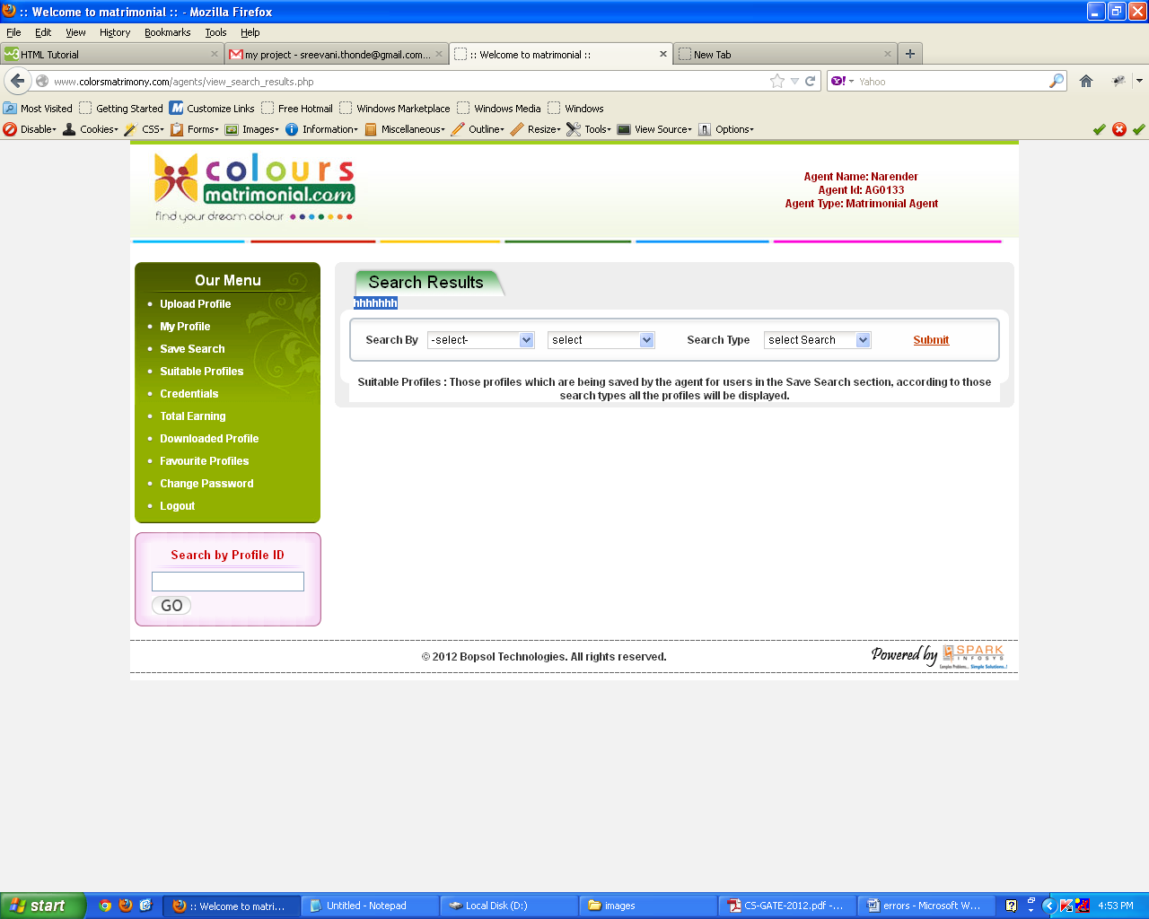
- Some error on search results like hhhhh

